**Milestone 3: Create the application**

**Instructions on how to build the application**

Team 2b

Jack Bentsen

PO Yu Chao

Chia Yu Hsu

Zhou Jin

***** **Create the database** *****

-- open MILESTONE2DUMP.sql on MYSQL

-- MYSQL connections option: use Local instance 3306

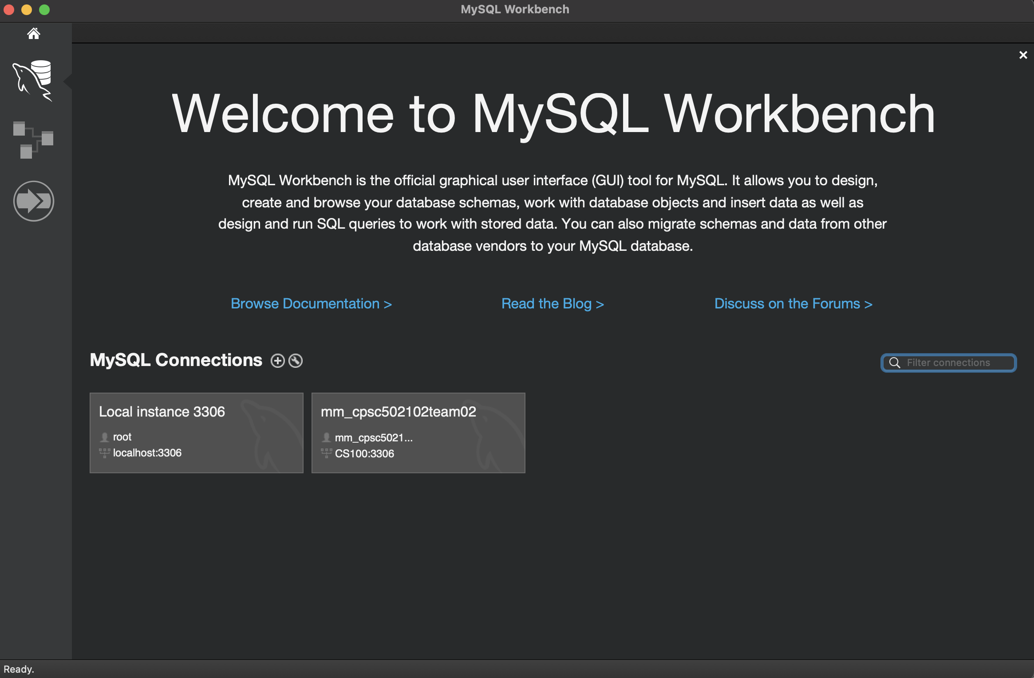

-- On MYSL:

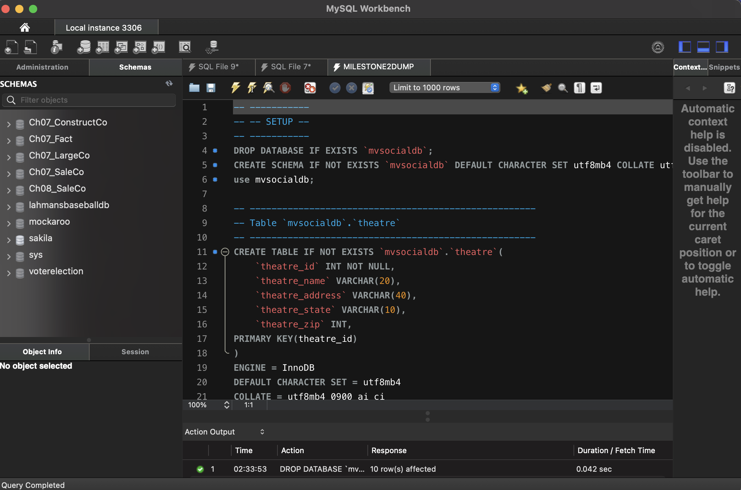

-- Execute the MILESTONE2DUMP script by clicking on the yellow lightning icon

-- Refresh SCHEMAS if no “mvsocialdb” is shown in the left SCHEMAS column

***** **Test Queries** *****

-- Open MILESTONE2QUERY.sql on MYSQL

-- Select line “USE mvsocialdb” first, then click on the yellow lightning icon to make sure it is using the correct database;

-- Select each query to test (from query start to the end “;”), and click on the yellow lightning icon to execute the query

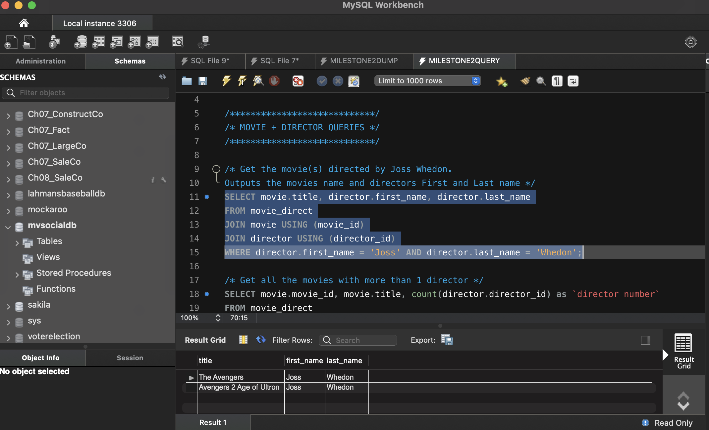

-- The results will be generated in the table format and detailed query descriptions are provided in the milestone2.pdf file

***** **Generate** t**he Internal Model** *****

-- Open milestone3.mwb on MYSQL and an ERD will display

***** **Option 1: Java – QueryRunner** *****

-- Open the QueryRunner.zip file with IntelliJ

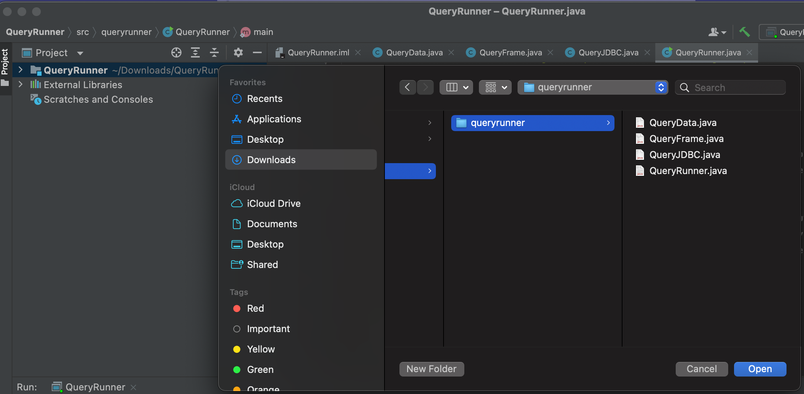

Inside the zip file:

* QueryRunner.iml
* QueryData.java
* QueryFrame.java
* QueryJDBC.java
* QueryRunner.java

-- Make sure all these files are included in the QueryRunner before running the program

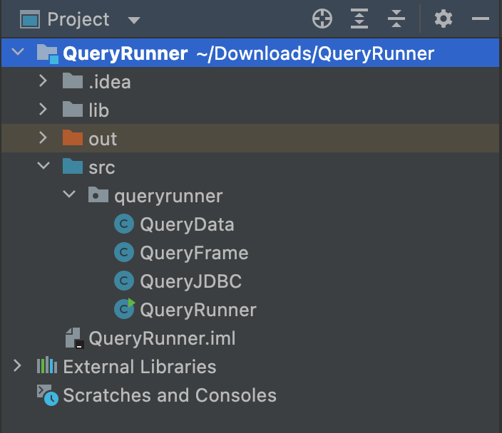

-- Click on the green triangle icon to run “QueryRunner”

-- Pop-up window will show as:

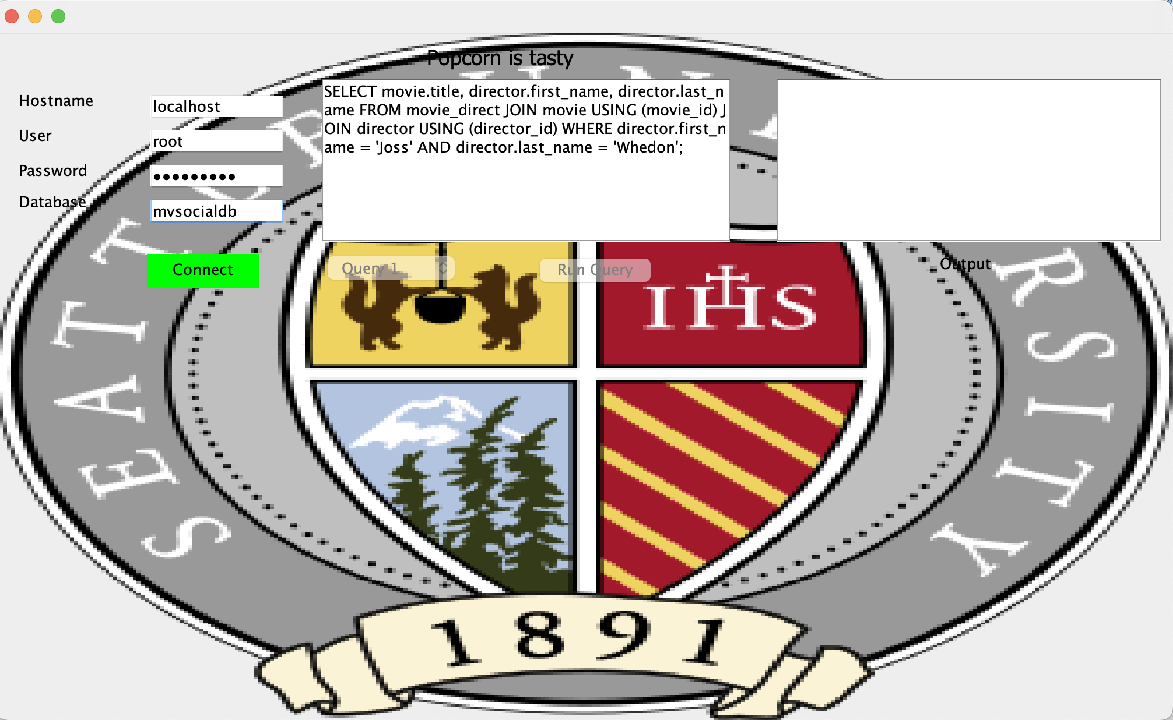

-- Use information:

* Hostname: localhost
* User: root
* Password: root password set for MYSQL
* Database: mvsocialdb

-- Then, click on “connect”

***** **Option 2: Run in console mode** *****

-- Edit configurations on Query Runner

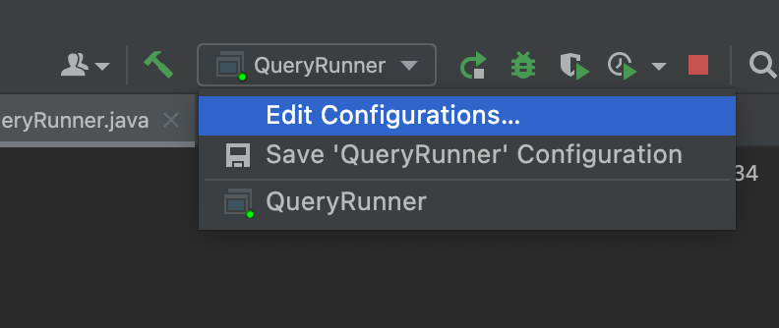

-- Put “-console” in the Program arguments, then press OK

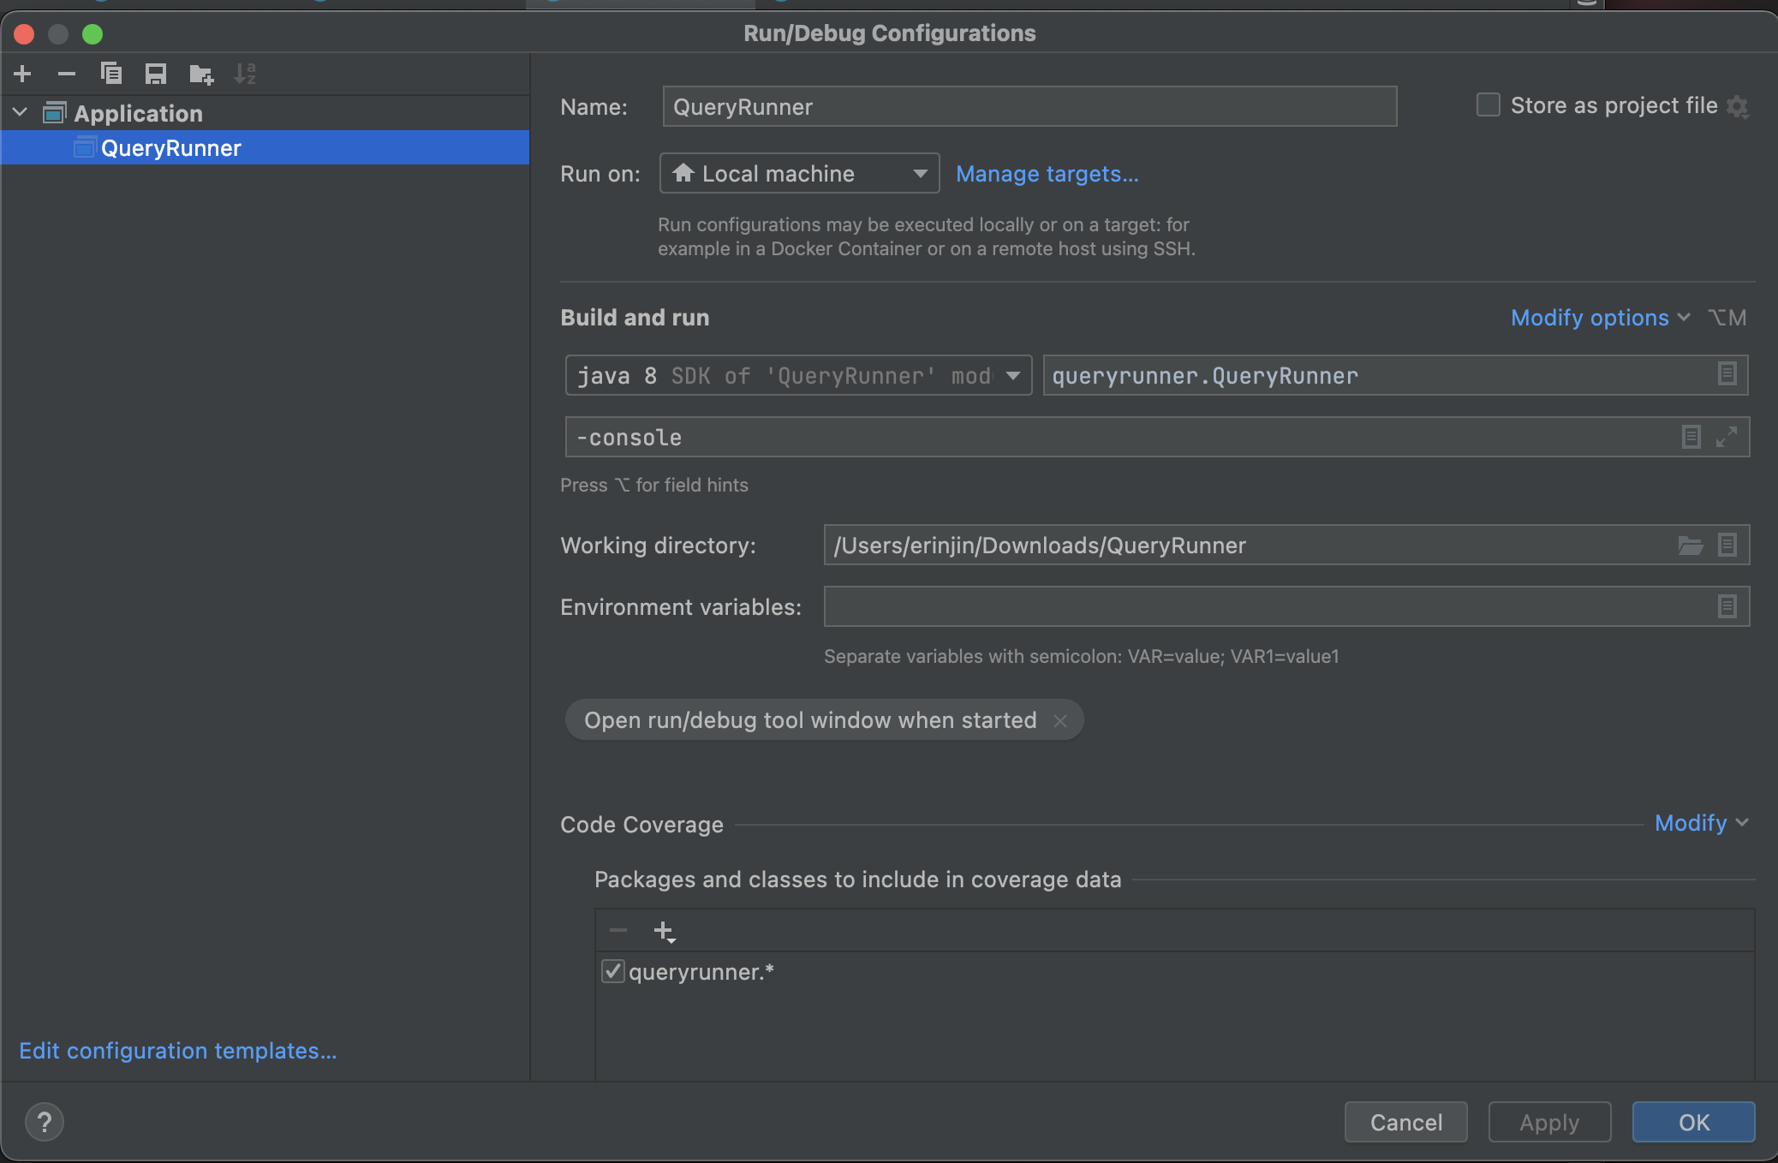

-- Run QueryRunner by hitting the green triangle arrow, and then type in your

Host name, username, password and database name

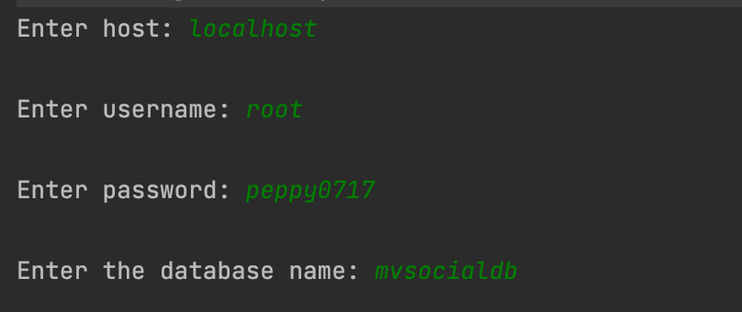

-- Then, select a query from the following:

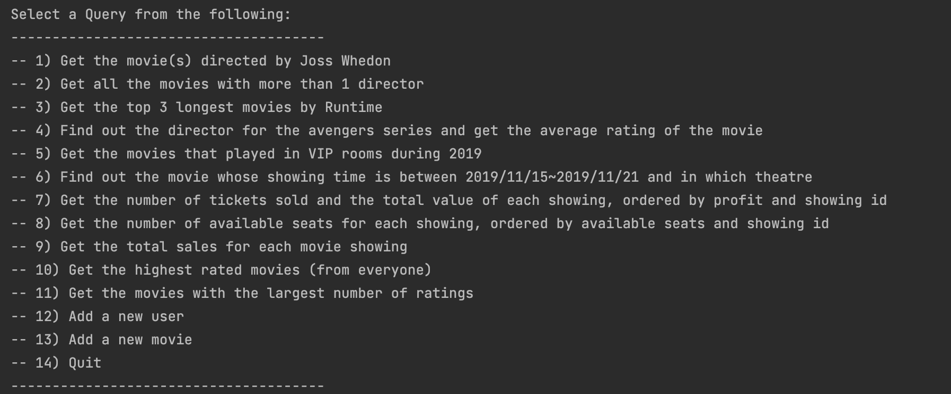

-- Enter query option (Integer 1 – 14)

-- Then, it will run with the selected query # and display the results

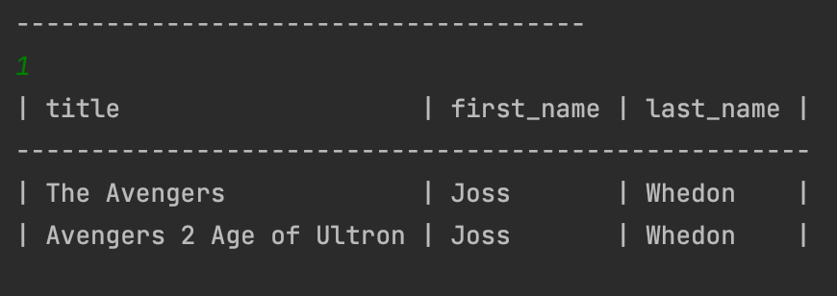

-- Enter 14 to quit

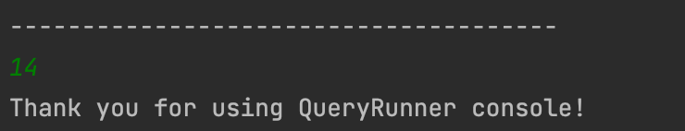

***** **Option 3: Use a runnable jar file** *****

-- Right click on QueryRunner project and select “Open Module Settings”

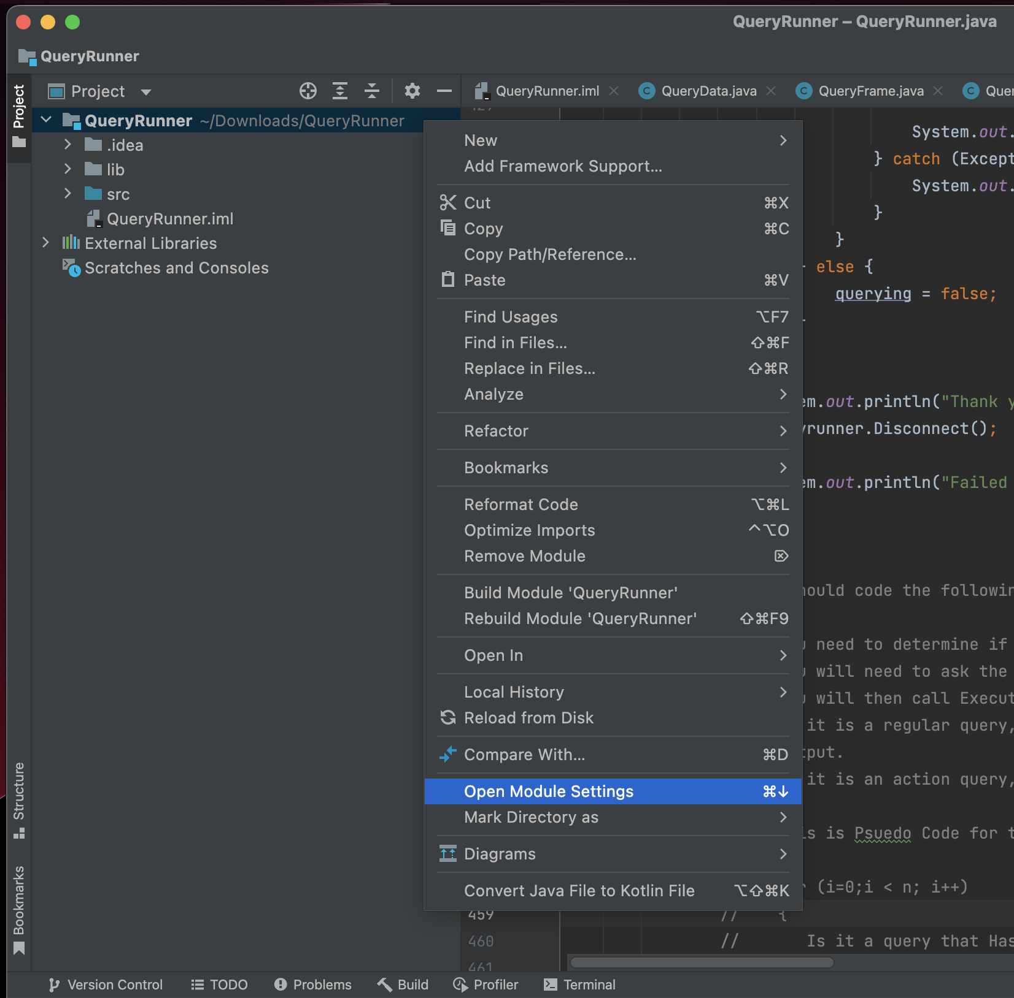

-- Select “Artifacts”, then click on “+”, select “JAR” and “From modules with dependencies”

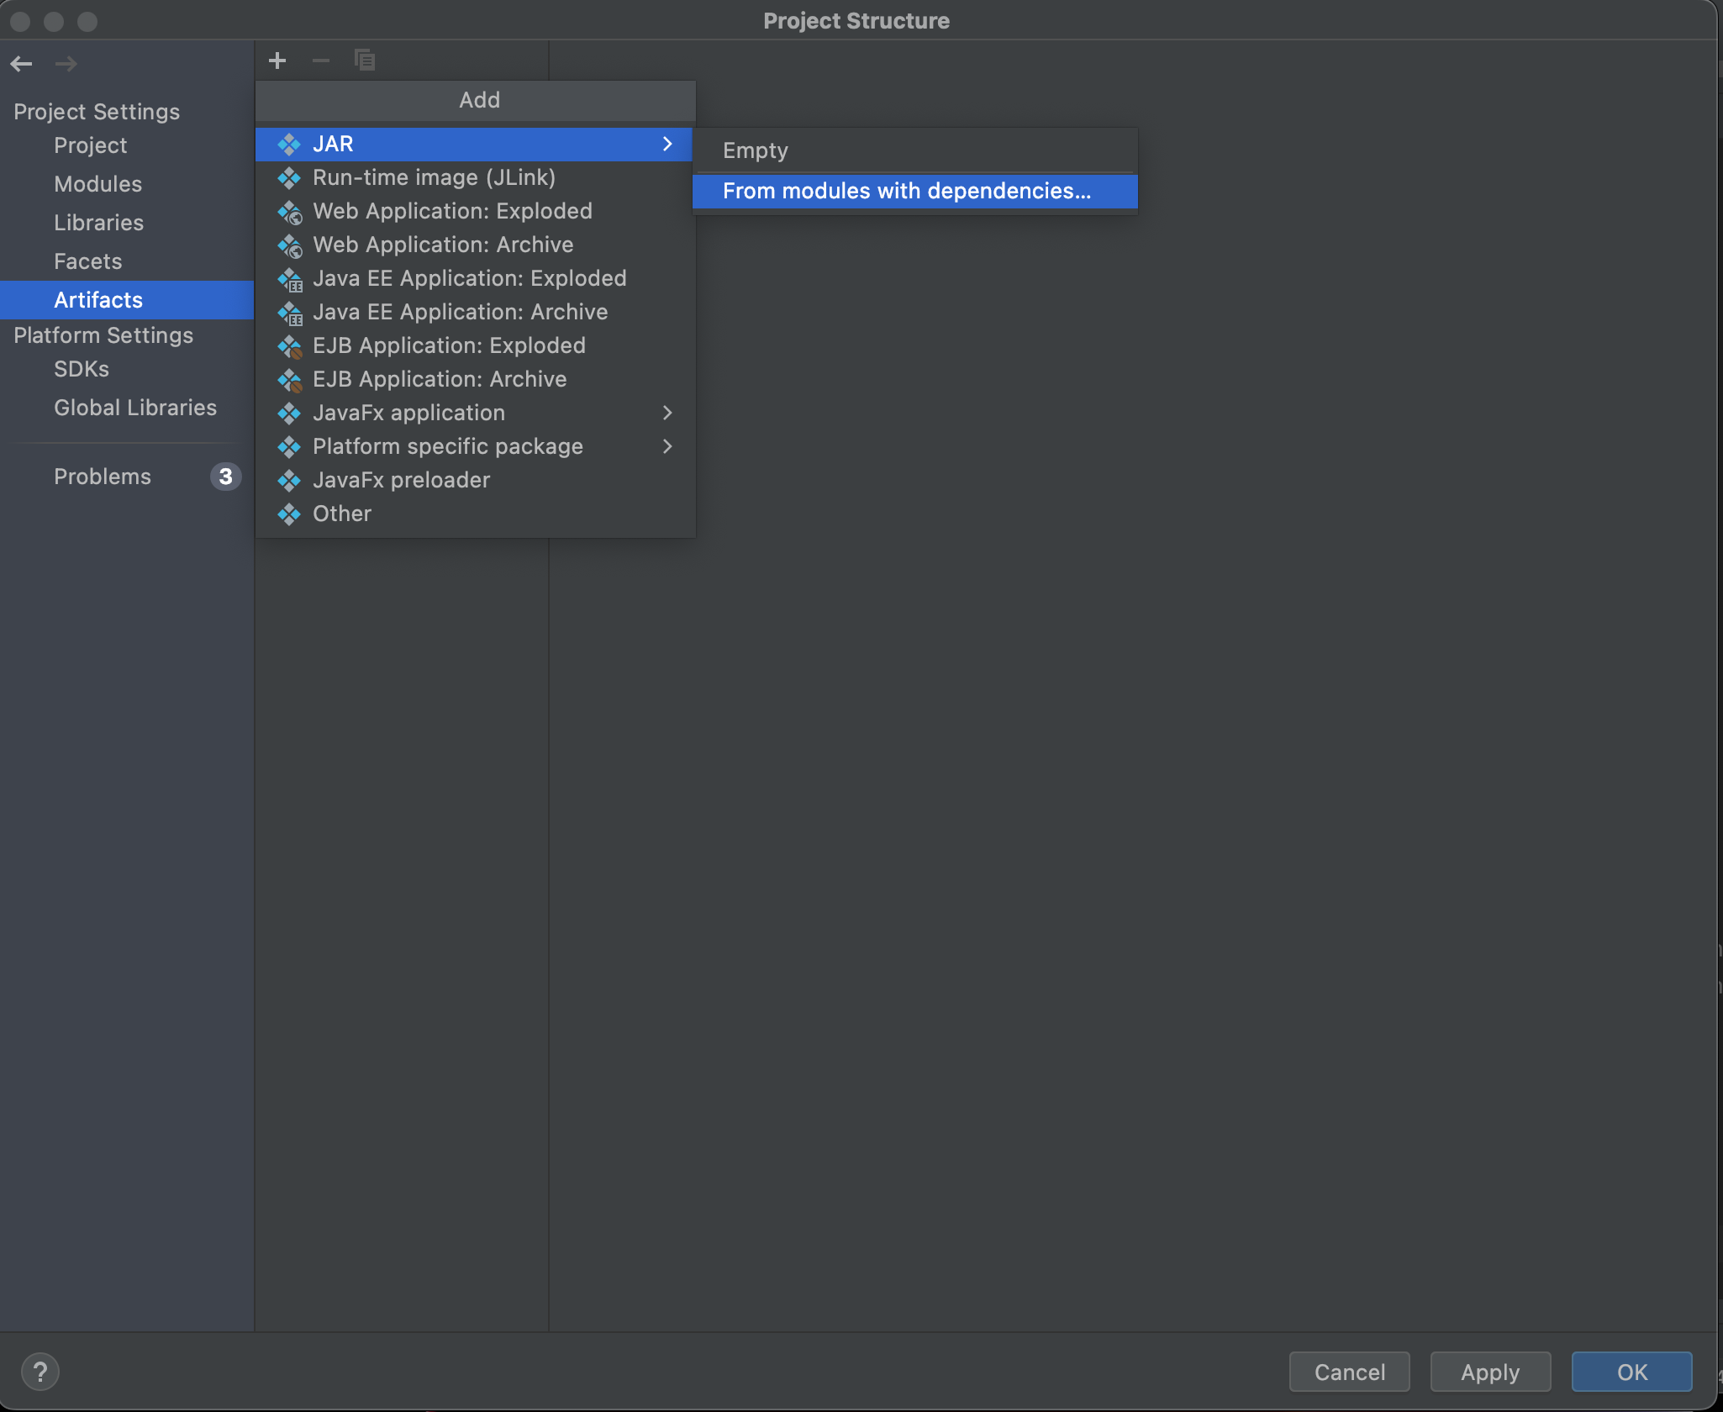

-- Click on the folder icon from “Main Class”

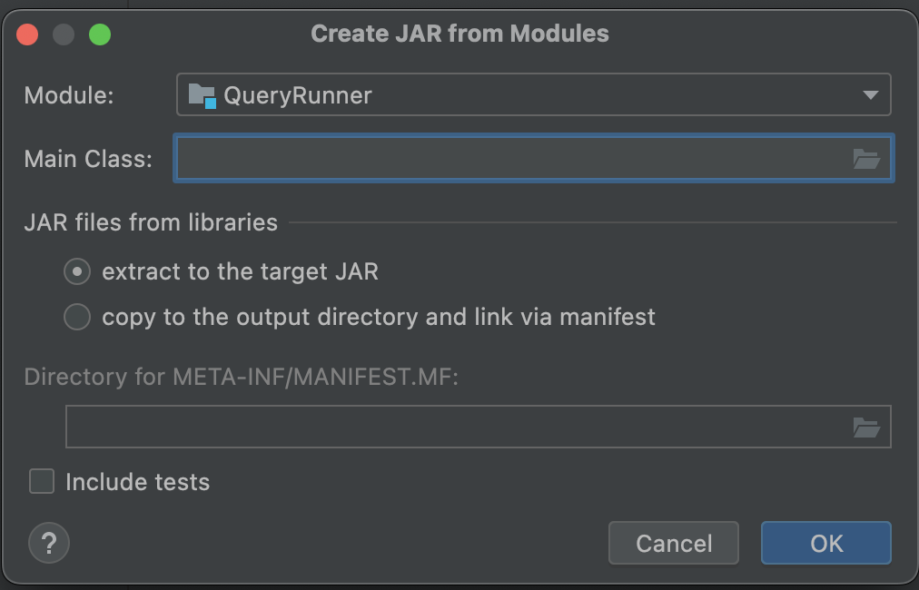

-- Choose “QueryRunner (queryrunner) QueryRunner” and click “OK”, and then it takes you back to the previous “Create JAR from Modules” menu

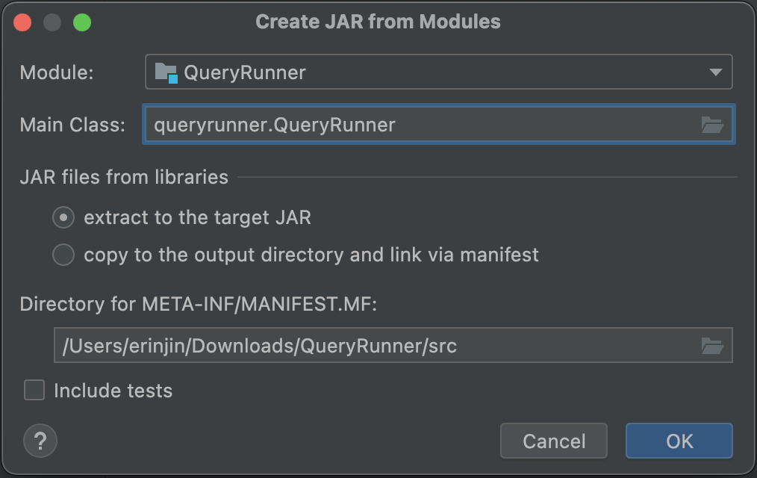

-- Click “OK”, and then from the following window, check “Include in project build”, and click on “Apply”. Finally, click on “OK”

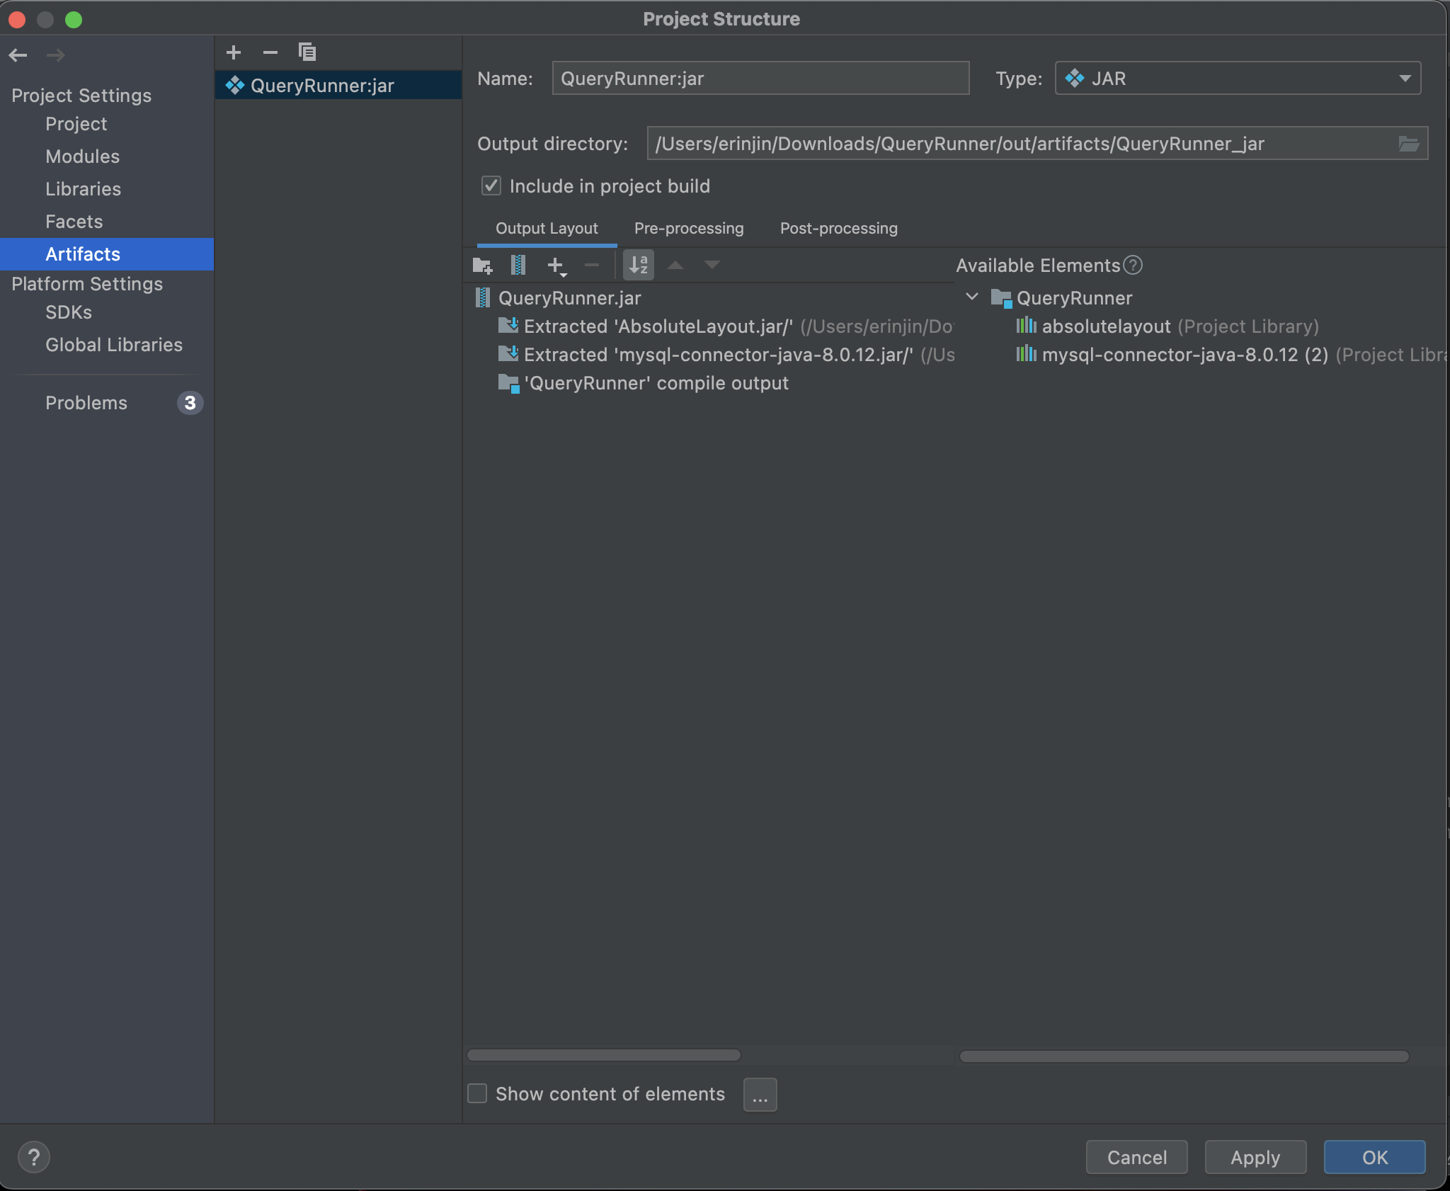

-- From the top menu, select “Build’, and click on “Build Artifacts”

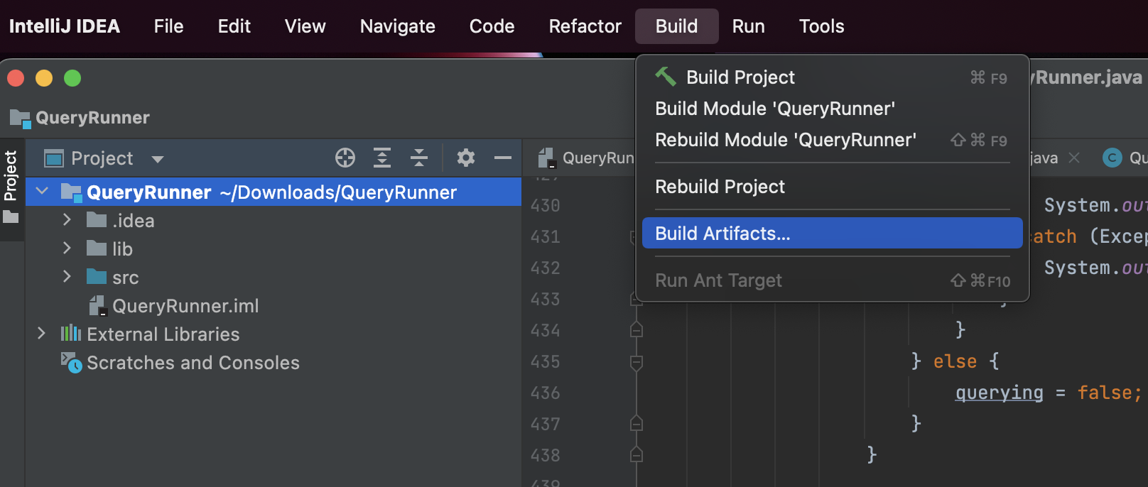

-- Click on “Build”

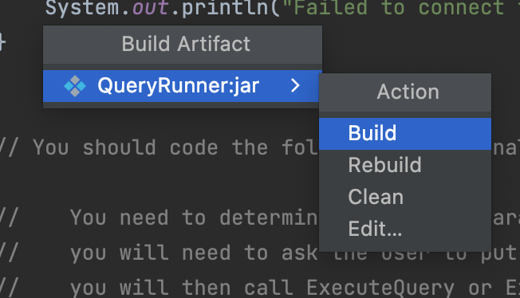

-- QueryRunner.jar file should be available in “out” files

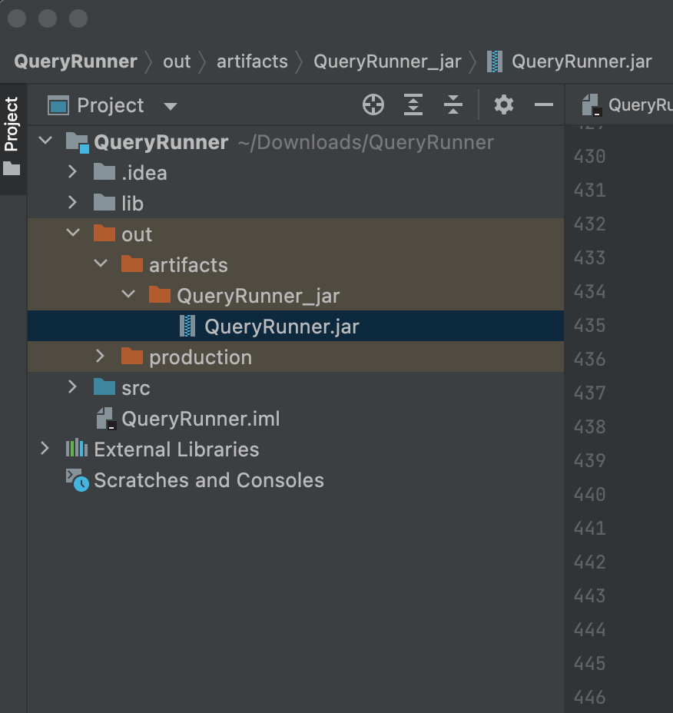

-- Then, click on “Edit Configurations”

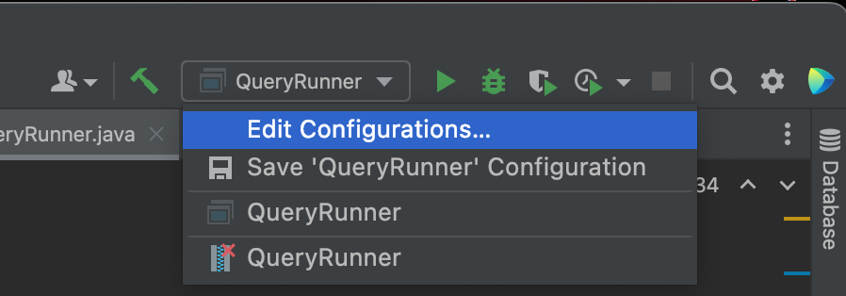

-- Click on “+” to add new configuration, and select “JAR” application

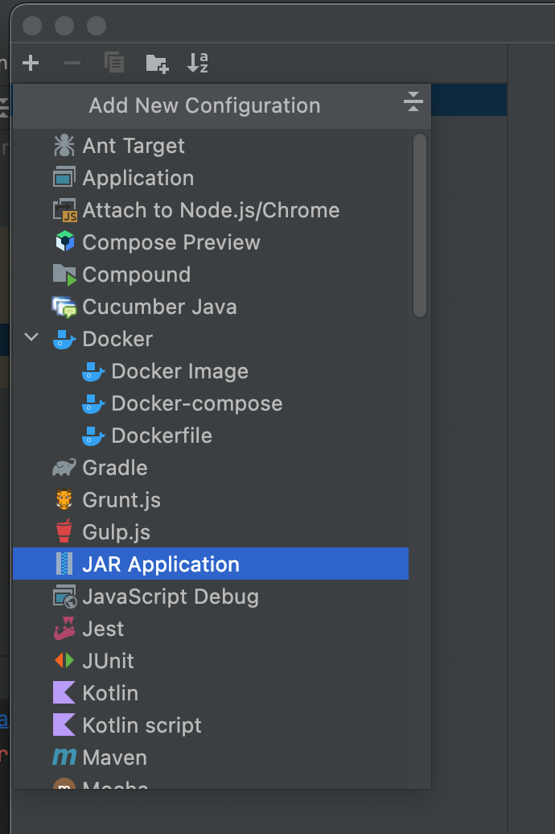

-- Type “QueryRunner.jar” to “Name”

-- Select the “QueryRunner_jar” folder just created for “Path to JAR”

-- Select the “QueryRunner” folder as “Working directory”

-- Choose “Default” for “JRE”

-- Then, click on “apply” and finally click on “OK”

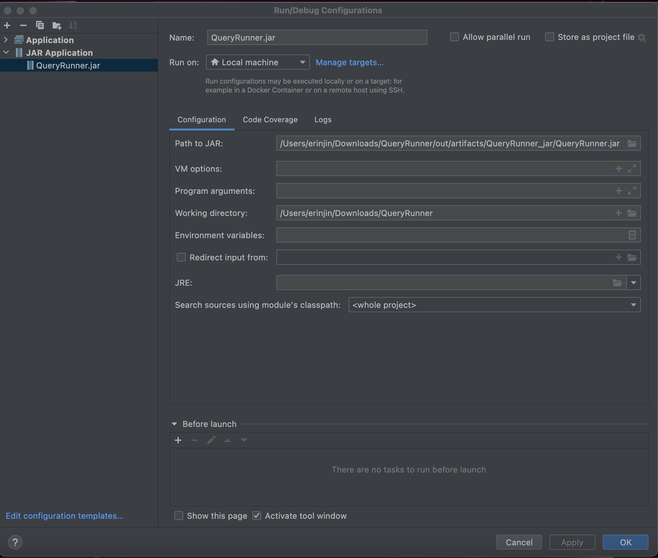

-- Now, the program is running using QueryRuner.jar as configurations

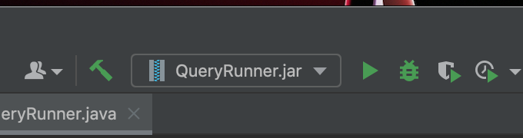

-- The same pop-up window shows

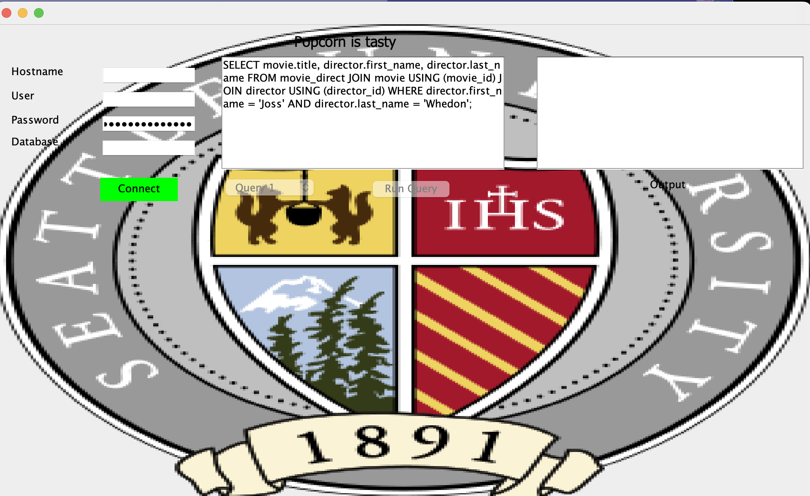

-- Use “java -jar QueryRunner.jar -console” on your local terminal to test

***** **GUI enhancement** *****

-- Some stylistic changes to GUI

- A background picture is inserted and will be displayed in the pop-up window

- Connect button changed color to green, and Disconnect button color to red

After connecting to the database, the “select Query #” will be available like so:



* Query options from Query 1 to Query 13 available

Query 1 –11 (with no parameters)

-- Scroll to select Query # and click on “Run Query” and the result displays below

-- Select different queries to generate different results to get an insight of the database

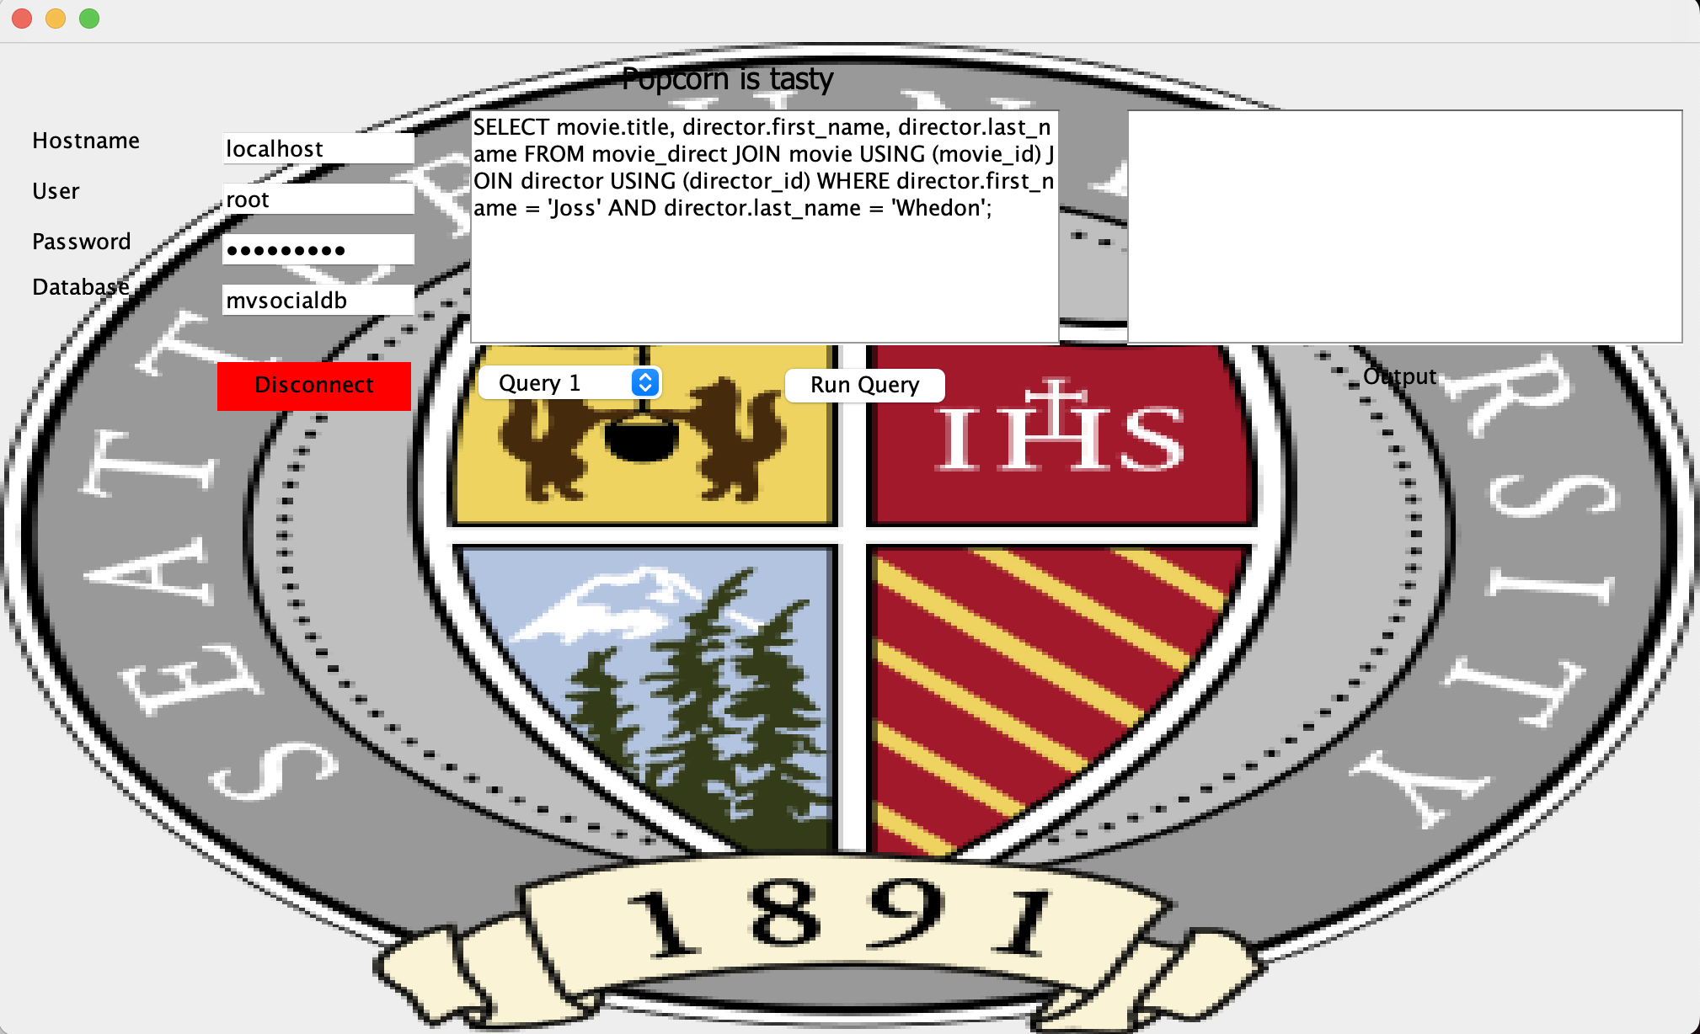

Query12 – Insert user information into the user table

-- Input parameters should be the same data types set in the user table (shown below)

* user_id:
* user_fname:
* user_lname:
* user_email:
* User_birthdate:

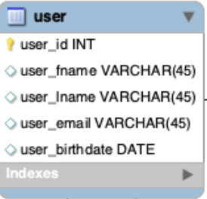

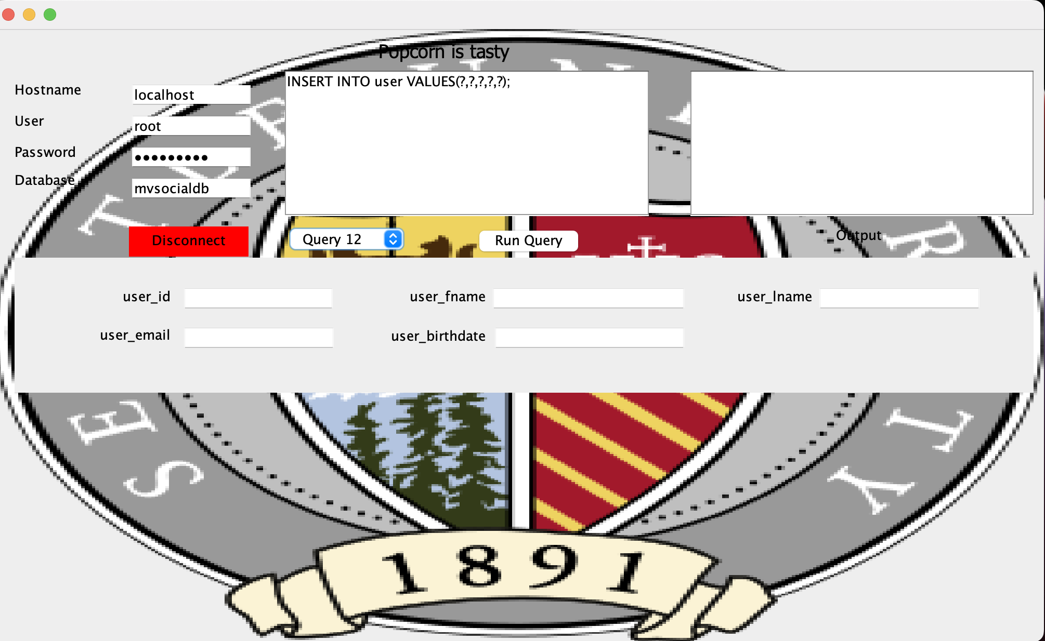

Query 13 – Insert movie information into the table movie

-- Input parameters should be the same data types set in the movie table (shown below)

* movie_id:
* title:
* Release_Year:
* Length_mins:
* Movie_country:

